SPRINT 1

|  |  |
| --- | --- |
| Project Title | Industry-specific intelligent fire management system |
| Team ID | PNT2022TMID34745 |
| Date | 17 NOV 2022 |

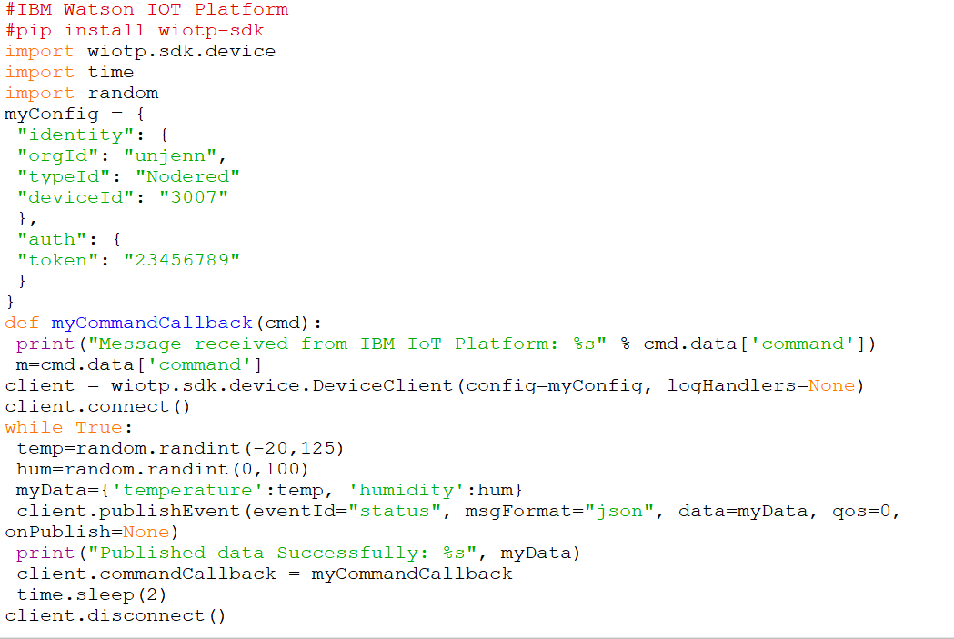

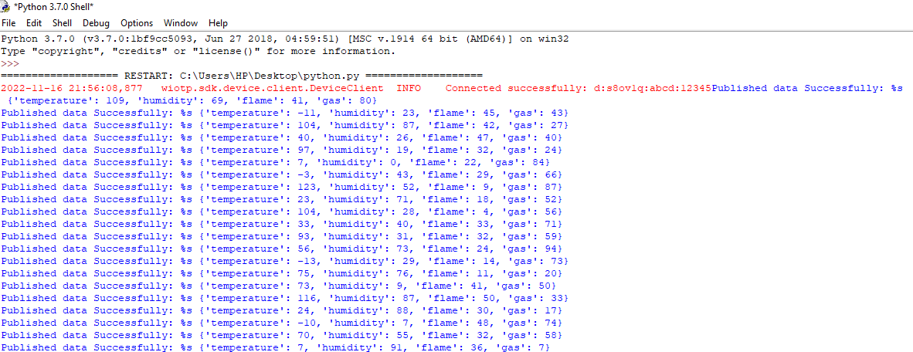**OUTPUT**

